Engineering Design

**SCROLL SAW machine**

Presented by: A.D.D.U.Kumara

Reg. No: UWU/SCT/19/047

Subject: Engineering Design

Subject code :375-1

**Content**

Introduction

Objective

Design

Problem

Mechanism

Methodology

Conclusion

References

**Introduction**

The scroll saw is a versatile and precise cutting tool that is commonly used in woodworking, metalworking, and other crafts. It is a type of machine that uses a thin, flexible blade to make intricate cuts in various materials. In this project, we will be designing and building a scroll saw machine that is specifically designed for cutting PCB and plastic materials. The blade is mounted on a reciprocating arm that moves up and down, allowing the user to make precise cuts with minimal sanding or finishing work. The scroll saw is a useful tool for creating intricate patterns and designs, as well as for cutting out complex shapes in PCB and plastic materials. This project will focus on the functionality and ease of use of the scroll saw machine specifically for cutting PCB and plastic materials.

**Objective**

The objective of this project is to design and build a scroll saw machine that is specifically designed for cutting PCB and plastic materials. The main goal is to create a machine that is capable of cutting these materials with precision and accuracy, while also being easy to use and maintain for the user. To achieve this, the project will focus on designing a machine that is safe to operate and meets all relevant safety standards. The construction of the machine will be executed keeping in mind the ease of use. The performance of the machine will be evaluated through testing and the results will be used to improve the design and construction of the machine based on user feedback. A detailed report will be provided on the design, construction, and performance of the scroll saw machine.

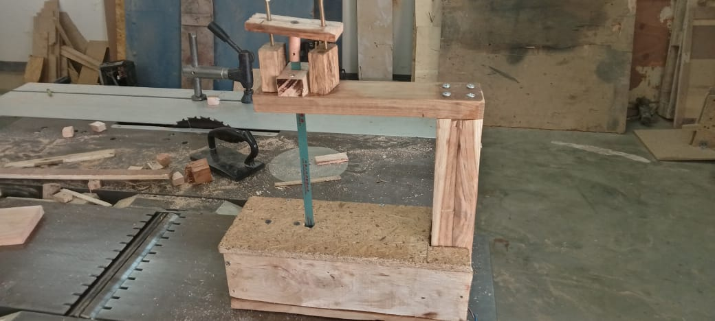**Design**

**Problem**

The project of designing and building a scroll saw machine specifically for cutting PCB and plastic materials poses several challenges. One of the main challenges is ensuring precision and accuracy in the cuts made by the machine. This requires precise measurements and calculations to be made during the design phase, as well as careful construction and testing to ensure that the machine is able to make precise cuts. Safety concerns are also a challenge, as operating a scroll saw machine can be dangerous if proper safety precautions are not taken. The project will need to ensure that the machine meets all relevant safety standards and that the user is protected from potential hazards. Sourcing the right materials for the construction of the scroll saw machine can also be a challenge, as certain materials may be more suitable for cutting PCB and plastic materials than others. Cost of construction is another challenge as building a scroll saw machine can be costly, particularly if specialized materials or equipment are required. The project will need to find a balance between cost and functionality to ensure that the machine is affordable while still meeting the project objectives. Another challenge is making the machine user-friendly, as it requires considering all the possible scenarios and providing solutions for them. Lastly, testing and evaluating the performance of the machine can also be a challenge as it requires specific equipment and resources.

**Mechanism**

The mechanism of the scroll saw machine for cutting PCB and plastic materials will involve the following main components:

Blade: The blade is a thin, flexible piece of steel or other suitable material that is used to make cuts in the PCB and plastic materials. The blade is mounted on a reciprocating arm that moves up and down, allowing the user to make precise cuts with minimal sanding or finishing work.

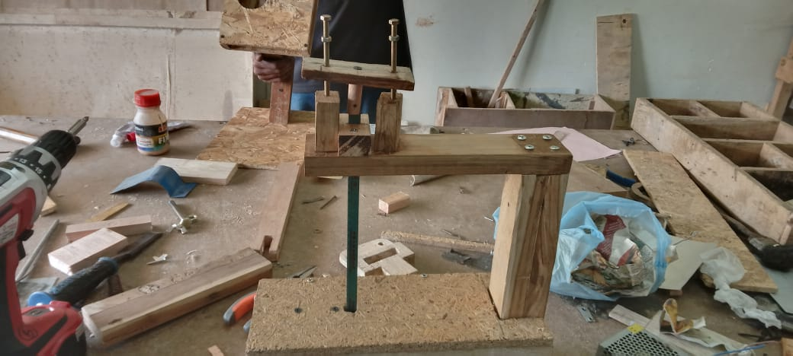

Table: The table is the surface on which the PCB and plastic materials are placed during cutting. The table should be sturdy and flat to ensure that the cuts are made accurately.

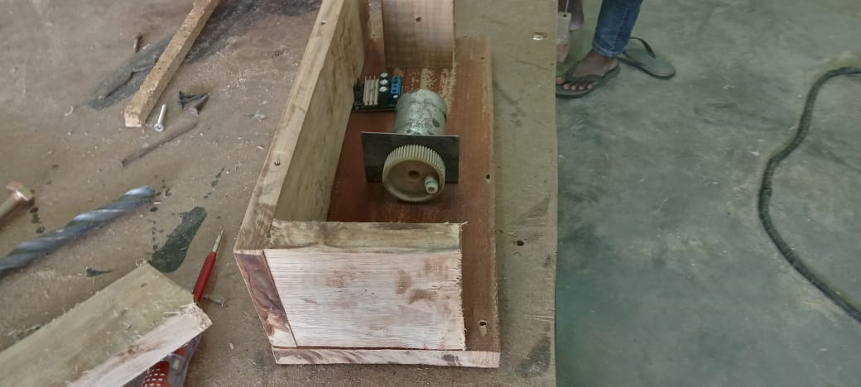Motor: The motor provides the power to drive the reciprocating arm that moves the blade up and down. The motor should be powerful enough to provide the necessary speed and torque to make precise cuts in the PCB and plastic materials..

Safety guards: Safety guards are installed to protect the user from potential hazards, such as contact with the blade or debris generated during the cutting process.

Control panel: The control panel is used to control the machine's operation, including turning the machine on and off, adjusting the blade speed, and making other adjustments to the machine.

Overall, the mechanism of the scroll saw machine will involve a combination of mechanical, electrical, and electronic components that work together to make precise cuts in PCB and plastic materials.

**Conclusion**

In conclusion, the project of designing and building a scroll saw machine specifically for cutting PCB and plastic materials has been a challenging and rewarding experience. The main objective of the project was to create a machine that is capable of cutting these materials with precision and accuracy, while also being easy to use and maintain for the user. The project team has put in significant effort to design and construct a machine that meets these objectives. The machine is designed with safety in mind and adheres to the relevant safety standards. The machine is also tested and evaluated to ensure its performance is up to the mark. The results of the testing have been used to improve the design and construction of the machine.

**References**

1. "The Complete Photo Guide to Framing: Second Edition" by Kent R. Johnson and Ellen Schmid.
2. <https://www.paoson.com/blog/en/make-your-own-scroll-saw-n39/>
3. <https://www.instructables.com/DIY-Homemade-Scroll-Saw/>